Morning Prayers
Dear God,
Help me spend today with a smile on my face,
love in my heart, joy in his grace
and my thinking cap on all day.
Amen.
St. Werburgh; pray for us.
St. Columba; pray for us.
St. ________; pray for us.
And all the other saints; pray for us.


Father in heaven, you love me,
you’re with me night and day.
I want to love you always in all I do and say.
I will try to please you, Father,
bless me through the day.
Amen.

Morning prayer
(linked to mission statement)

Hello, Lord Jesus,
Please help me to follow in your footsteps.

Teach me to place God at the centre of my life.

Show me how to care for others
as much as I care for myself.

Help me to make the kind of world you dreamed of.

I pray that I may make good choices
in all that I do and say.

I pray that I will consider others
and work to live peacefully with those around me,
so that I may grow to be the person God
made me to be,
the person God loves, and will always love.

Thank you for showing me the way.

Come Lord Jesus, be with us this day as we gather to bring your blessing upon our school.

Grace Before Meals
Bless us, O God
as we sit together.
Bless the food we eat today.
Bless the hands
that made the food.
Bless us, O God.
Amen.



Dear Jesus,
Thank you for the food
we are going to eat today.
Please bring food to those children
who haven’t got any.
Amen.

Grace After meals
Thank you, God,
for the food we have eaten.
Thank you God,
for all our friends.
Thank you, God, for everything.
Thank you, God.
Amen



End of Day Prayer
God Our Father, I come to say,
thank you for your love today.
Thank you for my family,
and all the friends you give to me.
Guard me in the dark of night,
and in the morning send your light.
Amen.


Now the day has ended,
we all sit here and pray,
that you’ll be with us always,
in all we do and say.
Look after us, watch over us, as we go on our way,
and bring us safe back to our school,
to enjoy another day.
Amen.


The God of life go with you,
The Risen Christ beside you,
The Vibrant Spirit within you.
Amen.
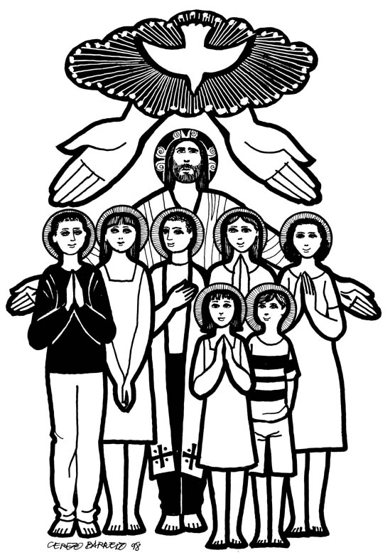

Act of Sorrow (contrition/sorry prayer)
Oh my God,
because you are so good
I am very sorry that
I have sinned against you,
and with the help of your grace I will try not sin again.


Other Prayers you may wish to use:
St.Werburgh’s & St.Columba’s School Prayer
Thank you Lord for this lovely new day. Bless all that we do and all that we say. Help us and guide us to take care of each other To share and be kind and to love one another. We ask you to guide us as we walk down life’s path As we follow in your footsteps to love, learn and laugh. St. Werburgh protects us St. Columba guard us. Amen.

The Apostles’ Creed.
I believe in God,
The father almighty,
Creator of heaven and earth.
I believe in Jesus Christ,
His only Son, our Lord.
He was conceived by the power of the Holy Spirit,
And was born of the Virgin Mary.
He suffered under Pontius Pilate,
Was crucified, died and was buried.
He descended to the dead.
On the third day he rose again.
He ascended into heaven,
And is seated at the right hand of the Father.
I believe in the Holy Spirit,
The holy Catholic Church,
The communion of Saints,
The resurrection of the body,
And the life everlasting. Amen
Advent prayer
Little baby Jesus
Born on Christmas Day
Coming down from Heaven,
For a while to stay.
Little baby Jesus
Arms extended wide
May I never, ever
Wander from your side.
Amen.

God, you love me and made me to be like you.
Help me to be more like
you by loving, forgiving
and caring for people.
Thank you God for loving me.
Amen

